Violins

For Sale
Emily Thompson Violin currently has one instrument for sale.
William Harris Lee, 2008
This instrument is handmade in the famous William Harris Lee Chicago workshop. The bright brown-gold varnish and ebony fittings match the high quality of the instrument's tone: powerful, complex, and with high, soprano overtones. $5000
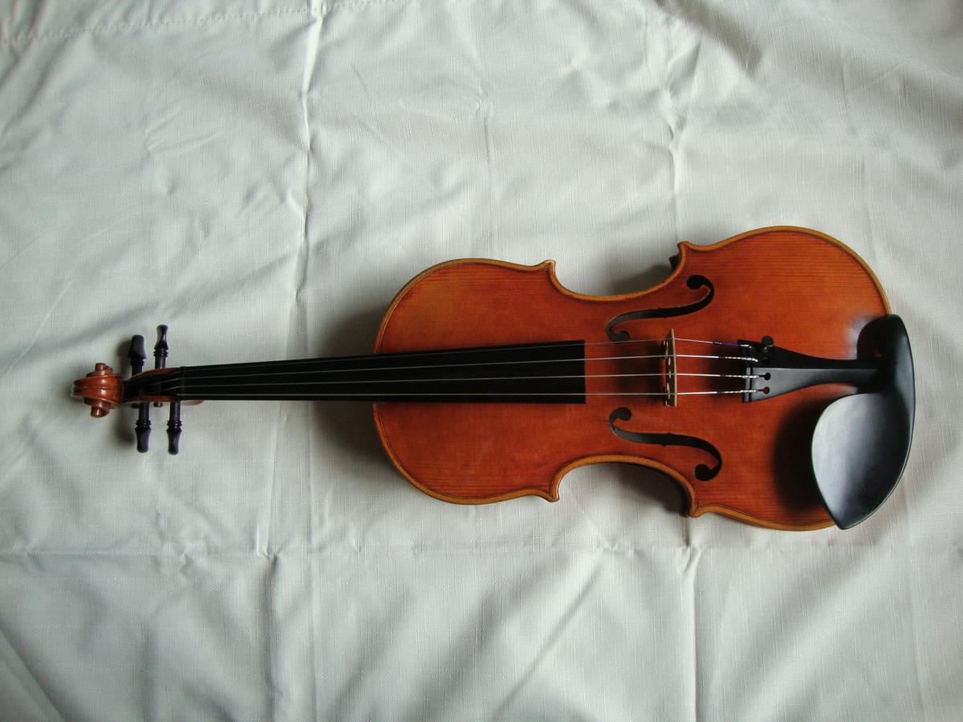

Please contact Emily for further details.

